**Feedback Control Systems**

**Lab Report 5**

**Hafiz Ahmad**

**19l-1316**

**Section-6B2**

**Block Diagrams Reduction using MATLAB**

**INTRODUCTION:**

In A single transfer function is all we need for control system analysis. There are three distinct sorts of associations between move capability that are typically experienced by and by: closed-loop transfer functions with feedback connections, parallel connections, and cascade connections. MATALB's commands make it easy to get these transfer functions. The following commands are used to obtain the transfer functions of cascaded, parallel, feedback, and unity feedback systems, respectively: [ num, den] is equivalent to series (num1, den1, num2, den2), parallel (num1, den1, num2, den2), feedback (num1, den1, num2, den2), and cloop (num1, den1, -1).

**OBJECTIVES:**

1. To obtain transfer functions of complex block diagrams through MATLAB.

2. To plot the responses of systems

**Procedure:**

**Tasks:**

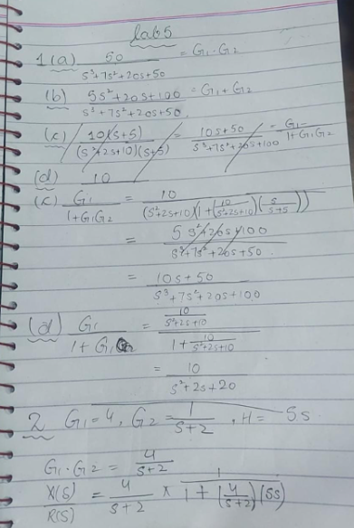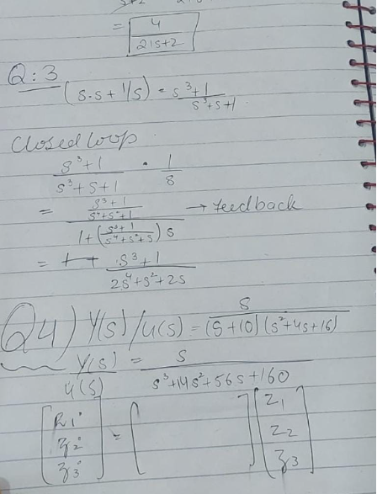

**Task on MATLAB:**

Q.1 (a)

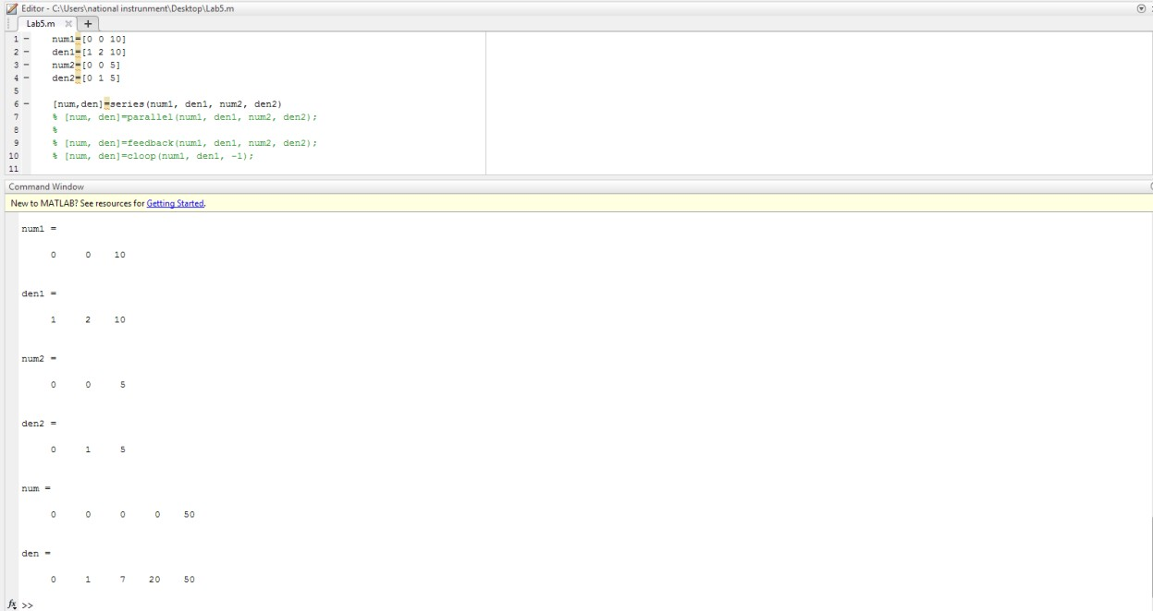

Q.1 (b)

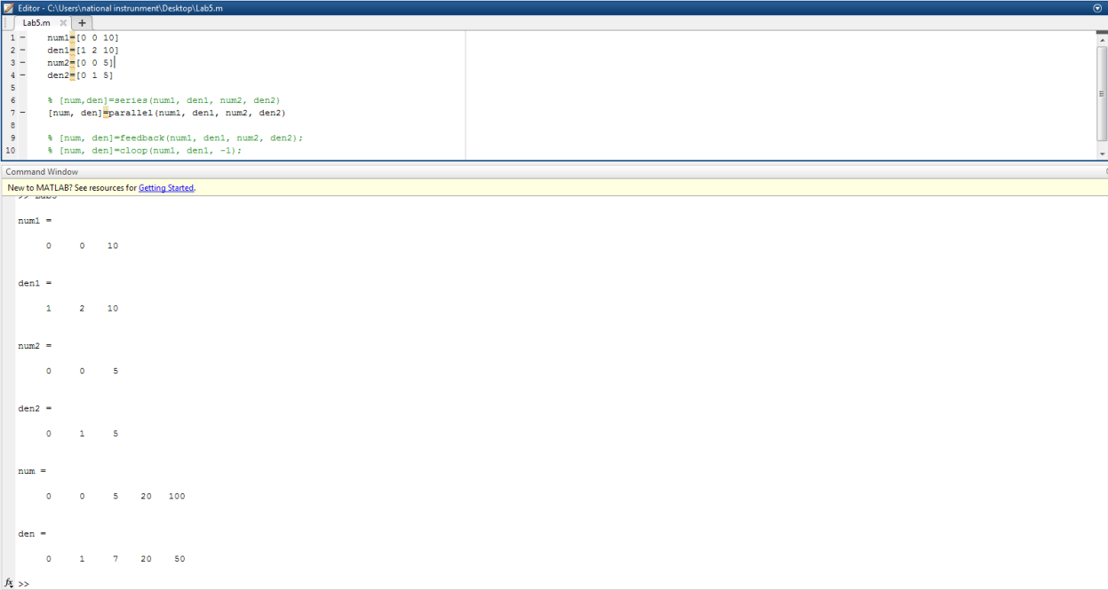

Q.1 (c)

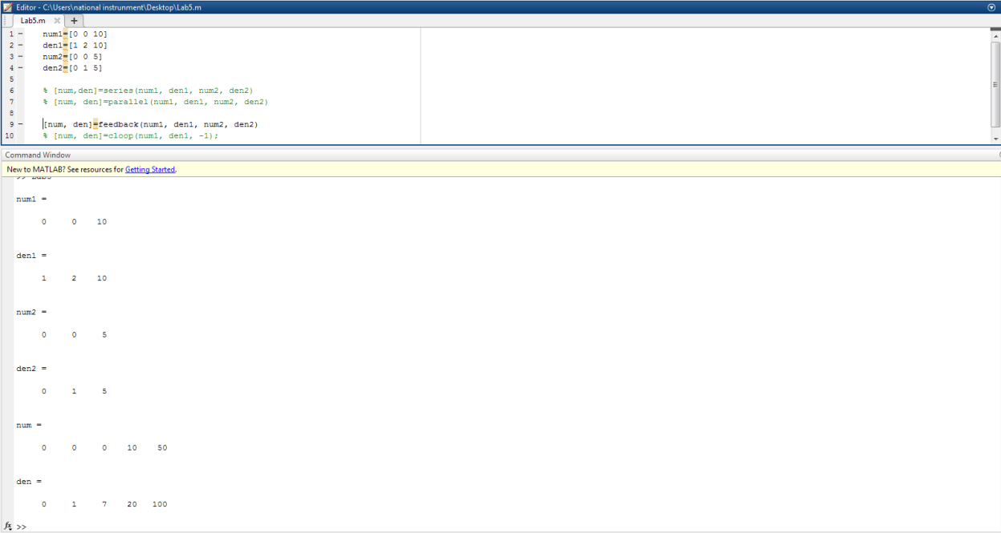

Q.1 (d)

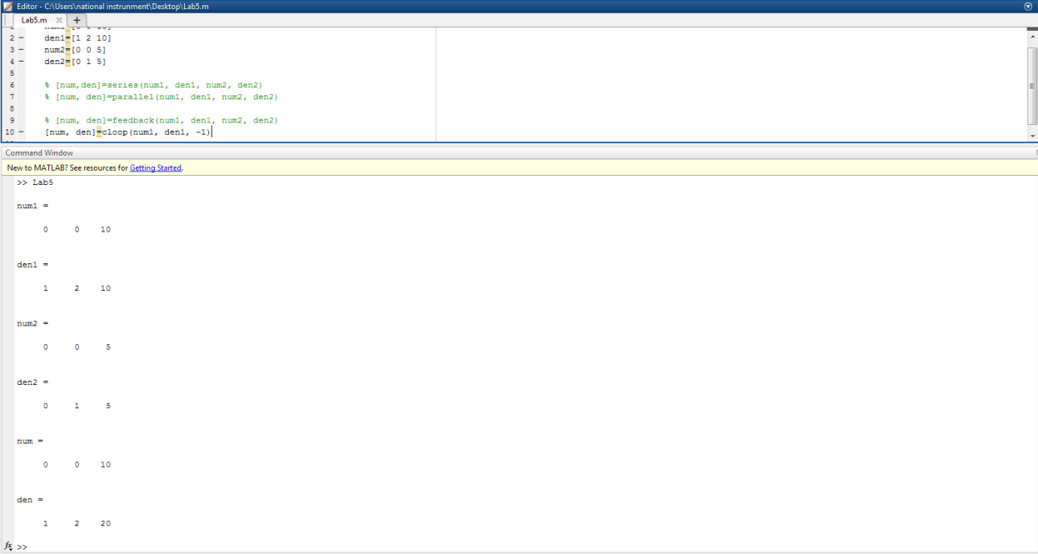

Q.2

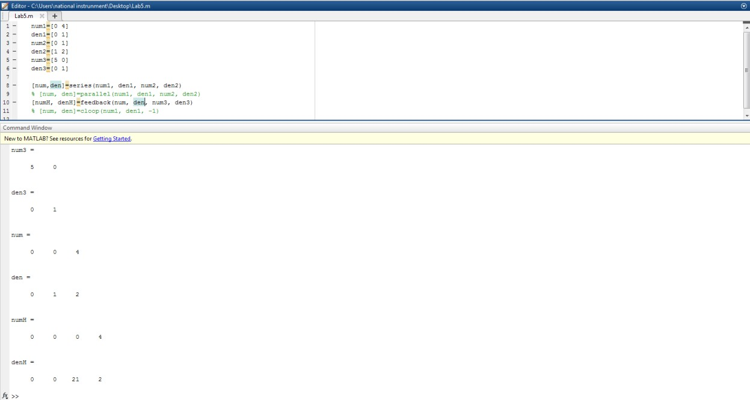

Q.3

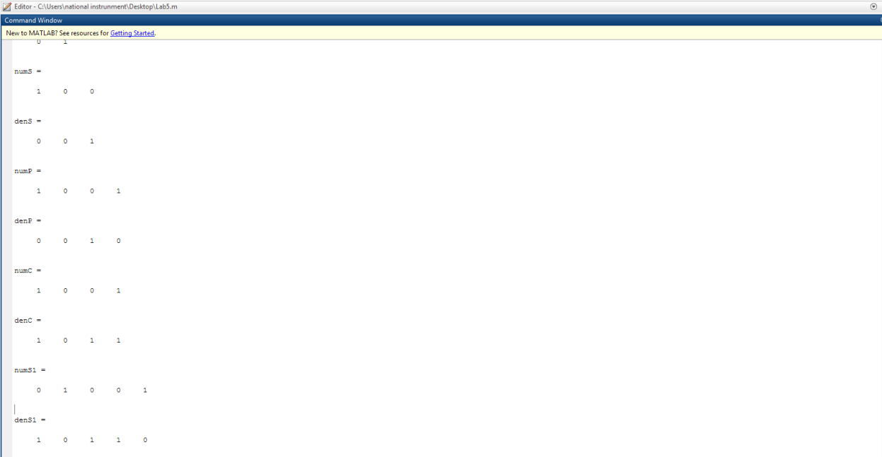

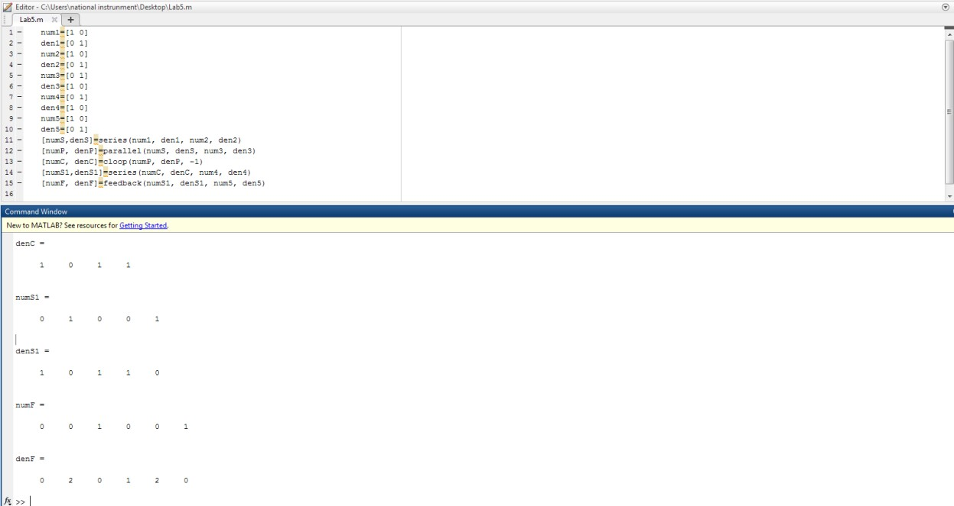

Q.4(a)

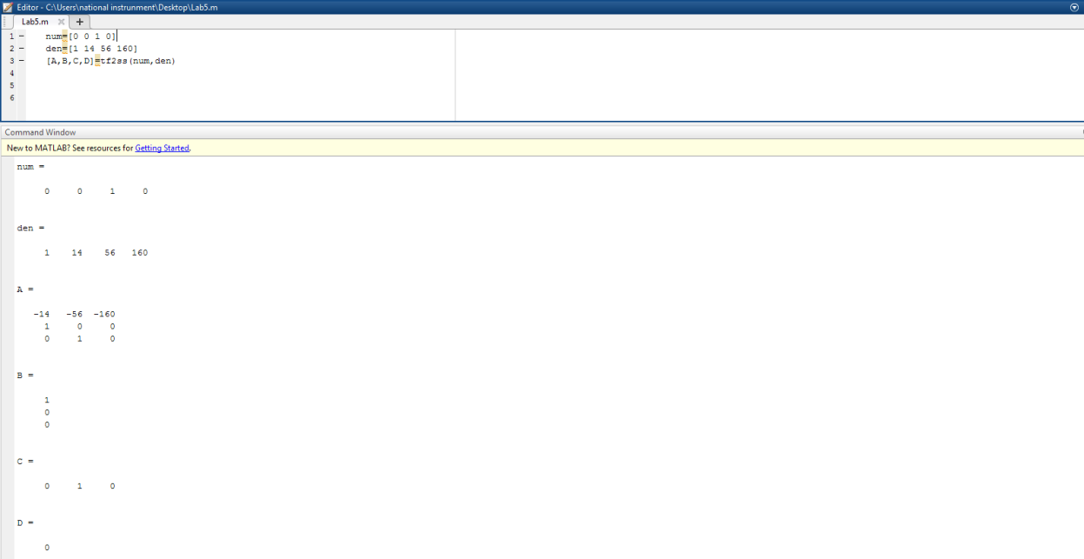

Q.4(b)

Q.5(a)

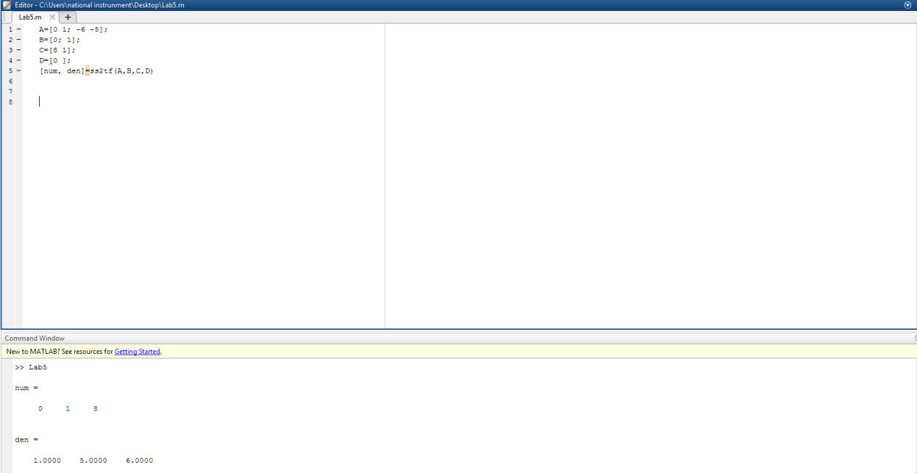

Q.5(b)

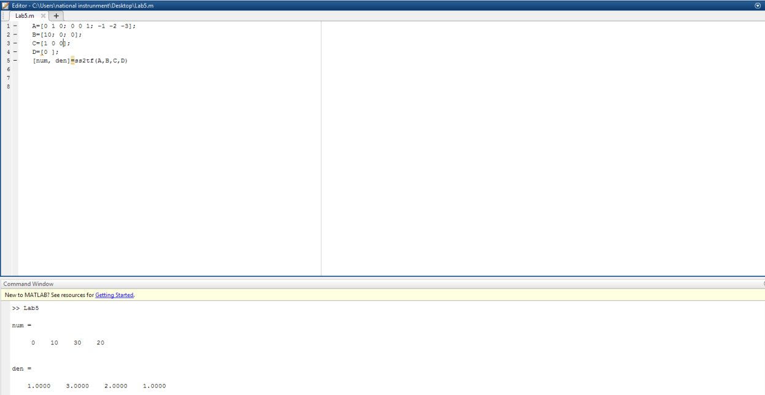

Q.6

**Application:**

By doing this experiment When developing and describing hardware or software systems as well as representing their workflows and processes, a block diagram is an essential method. Electronics uses block diagrams to show systems and how they change, like the trucking industry's mechatronic systems.

**Issues:**

No issue found while performing the lab.

**Conclusion:**

In this lab we learn MATLAB helped us comprehend the reduction of the block diagram.

**Post lab:**

**Q1. Given a mass-spring damper system B=damping constant M=mass K=spring constant F=u=force the state space model for this system is shown below**

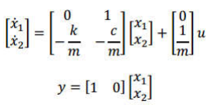

1. **Define the state-space model above using the ss function in MATLAB. Set c=1, m=1, k=50.**

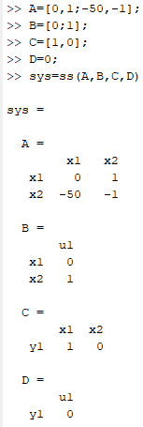

1. **Use MATLAB to simulate the result. Explain each step in detail.**

For using the giver state space equation in MATLAB first eve defined all the variables required for ss function then we called ss function and inserted those variables in it.

1. **Find the transfer function from the state-space model.**

As Tf=C(sI-A)-1B+D

=

1. **Find the responses of the system using SIMULINK and insert the screen shots.**

